**SnowFlake Case study**

**-Sai Ritheshwar**

**Scenario**

You’re the data engineer at **ItTechGenie Retail**. Sales teams drop monthly CSVs into an **Azure Storage** container. You must:

1. upload the CSV to Azure,
2. ingest it into **Snowflake** using **Snowpark**,
3. model it into proper **database/schema/table**, and
4. build a quick **Power BI** report for business users.

Steps:

1.Creating blob storage in azure

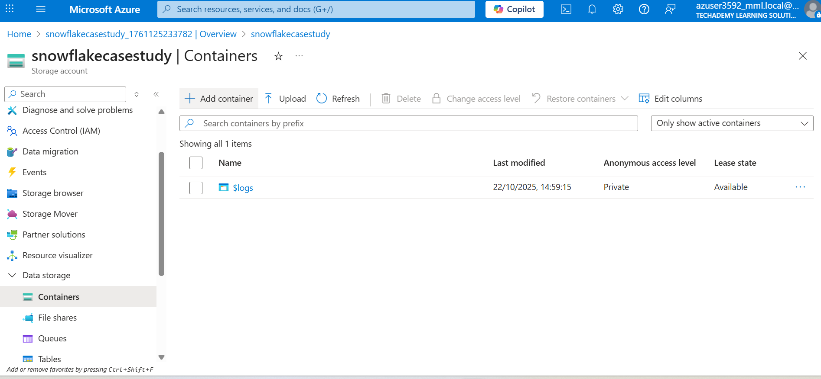

2.Creating a container and adding the dataset

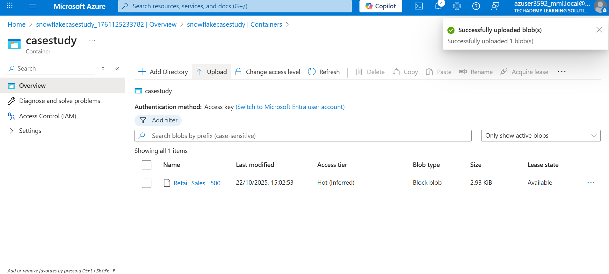

3.Generating SAS token for the container

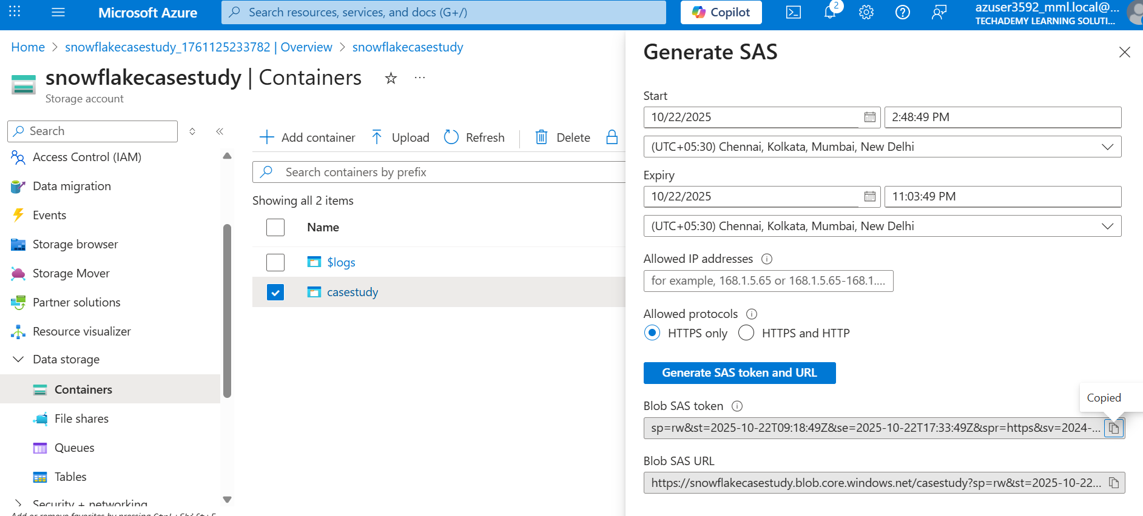

1. Creating an external stage on snowflake to mount the azure blob

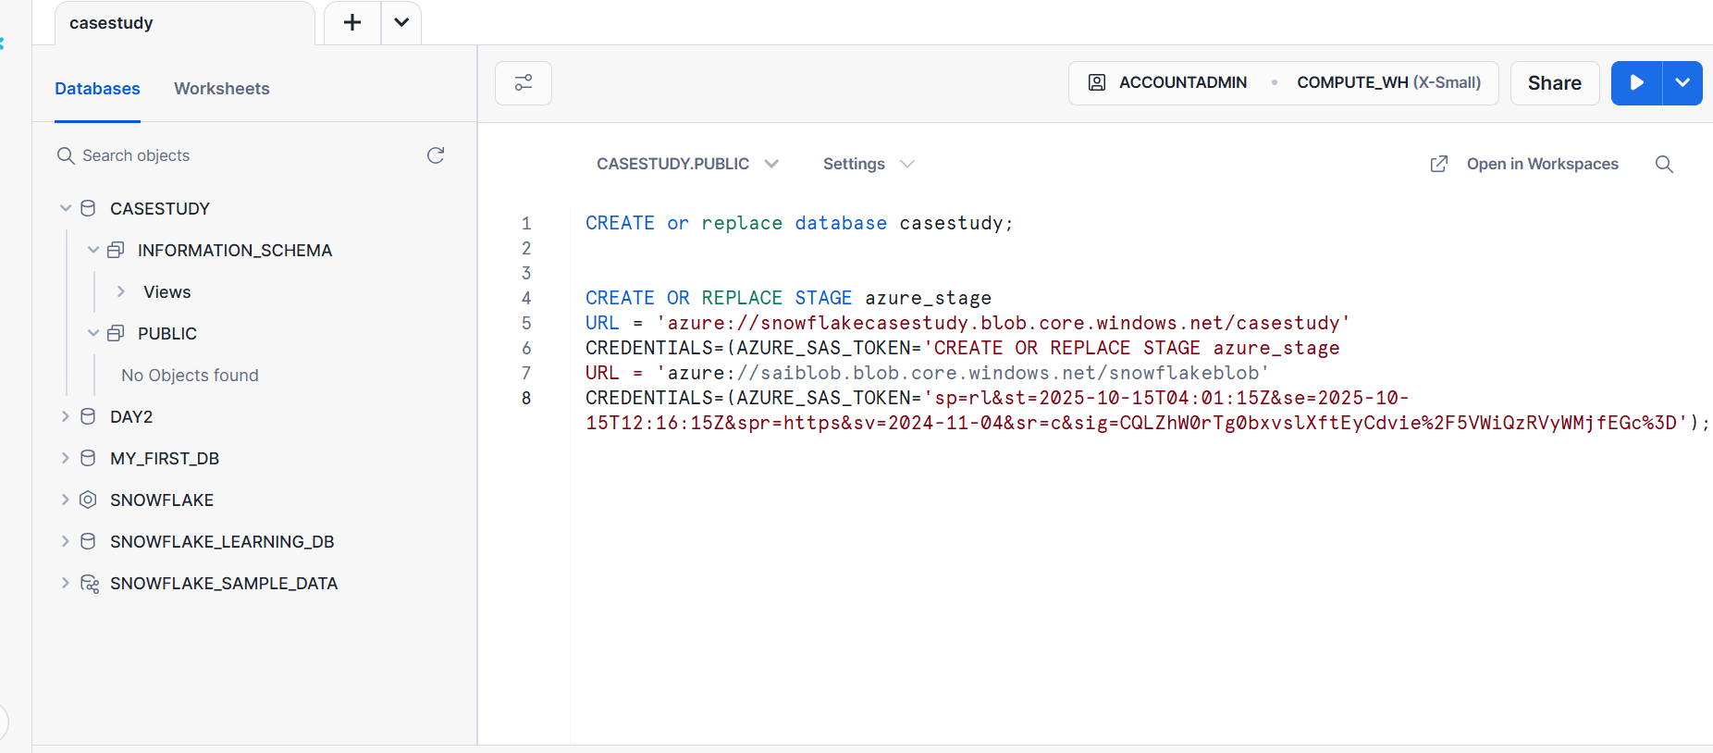

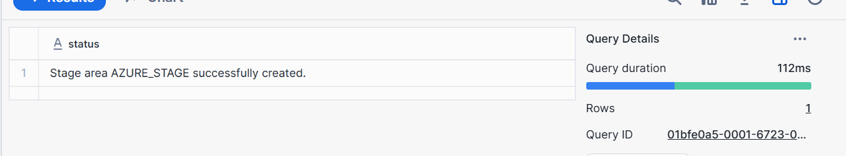

6.Listing the files present in the stage

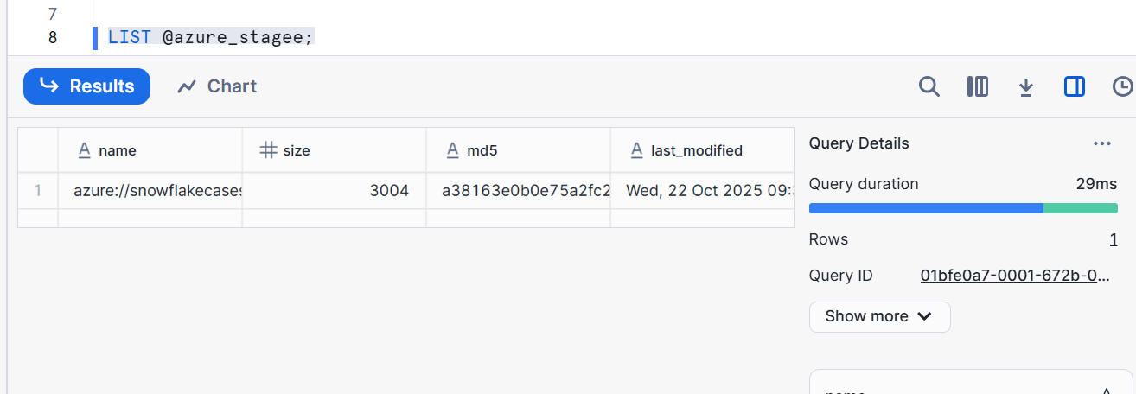

7.Creating target table to load from external stage

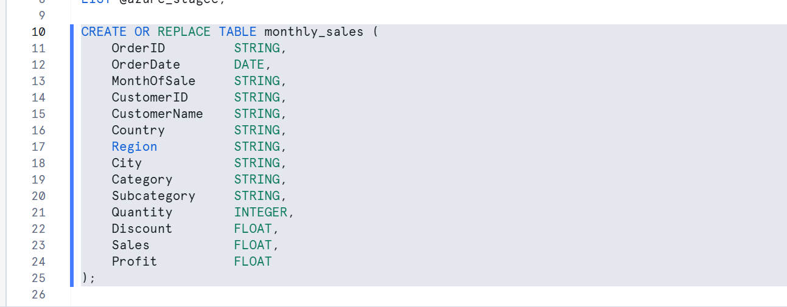

8. Creating a file format

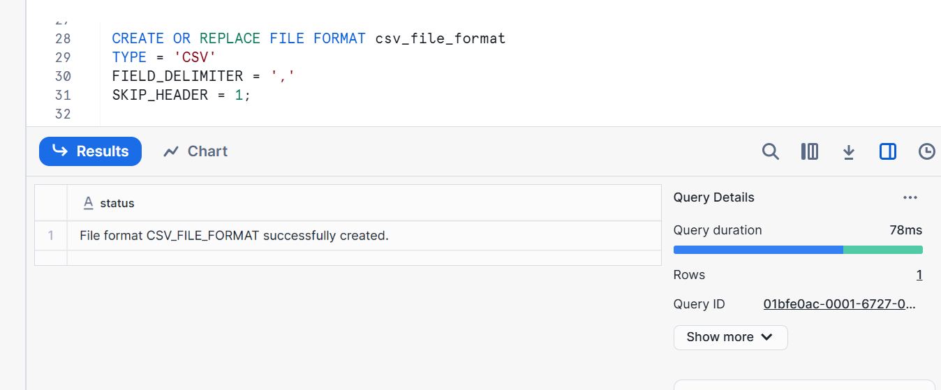

9. loading into the table

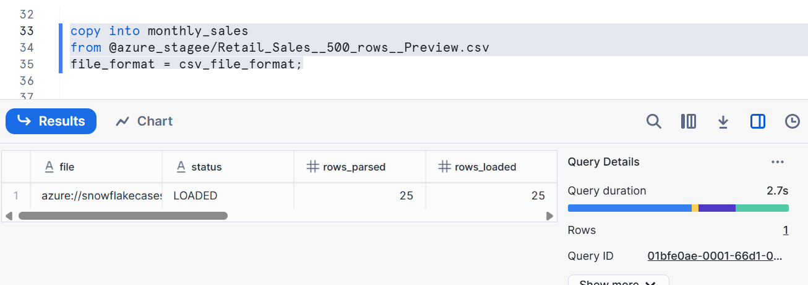

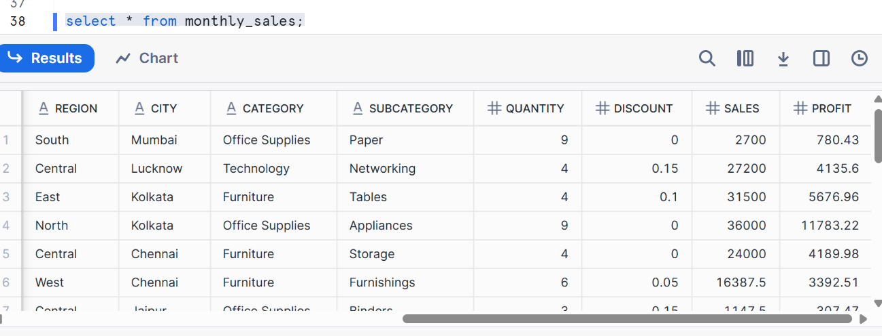

10.Using snowpark to ingest data into snowflake:

Creating a databricks environment

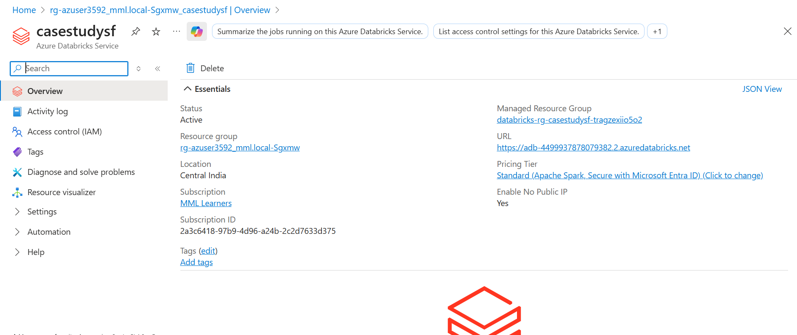

11.creating cluster and installing the library

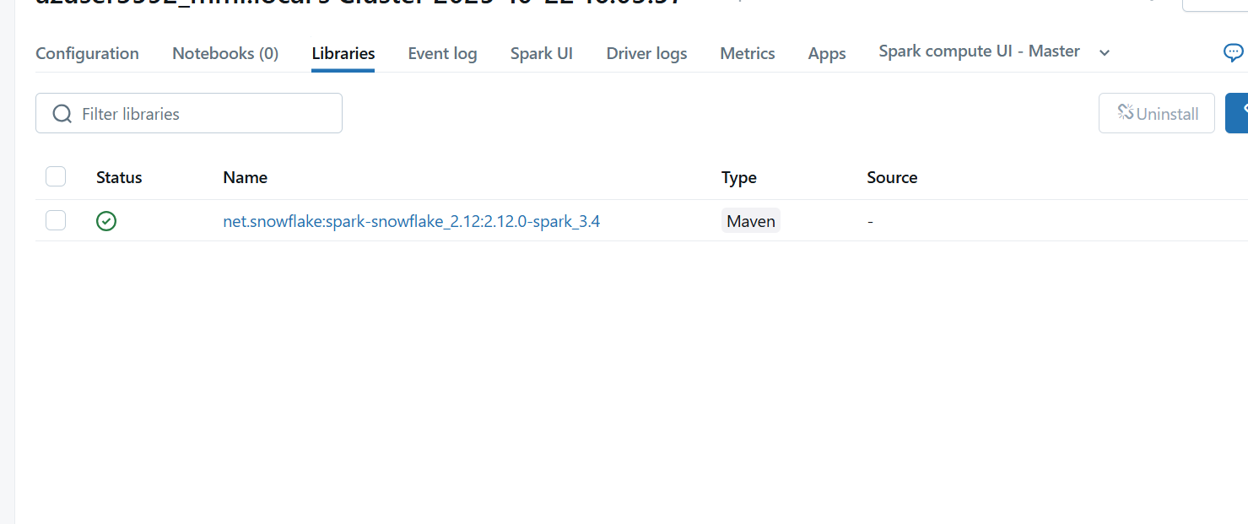

12.Ingesting data

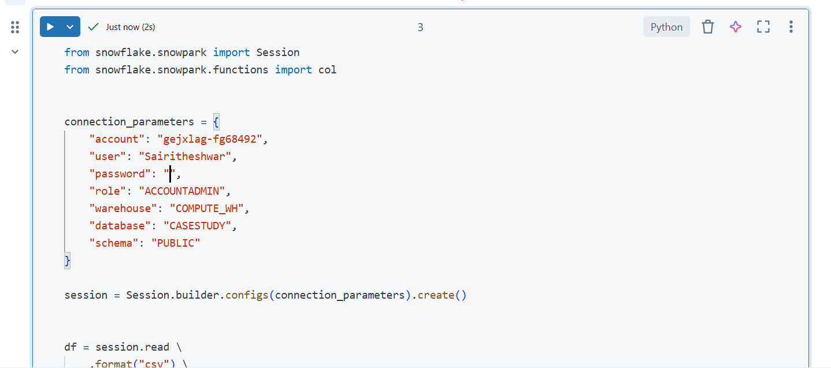

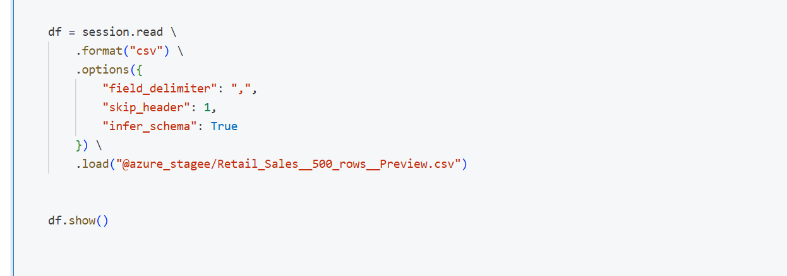

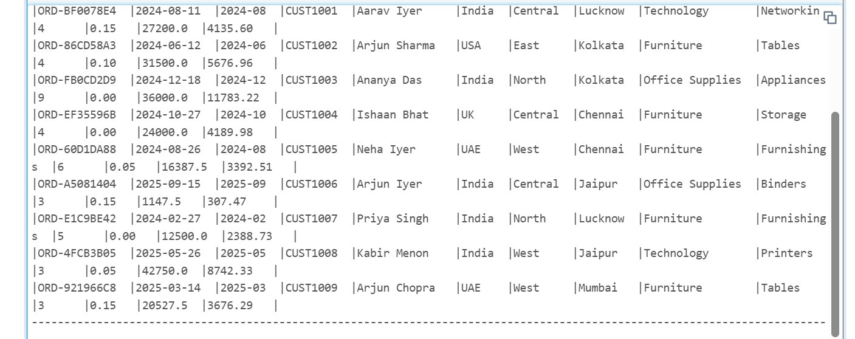

13.Creating a new target table for the data to be loaded from databricks

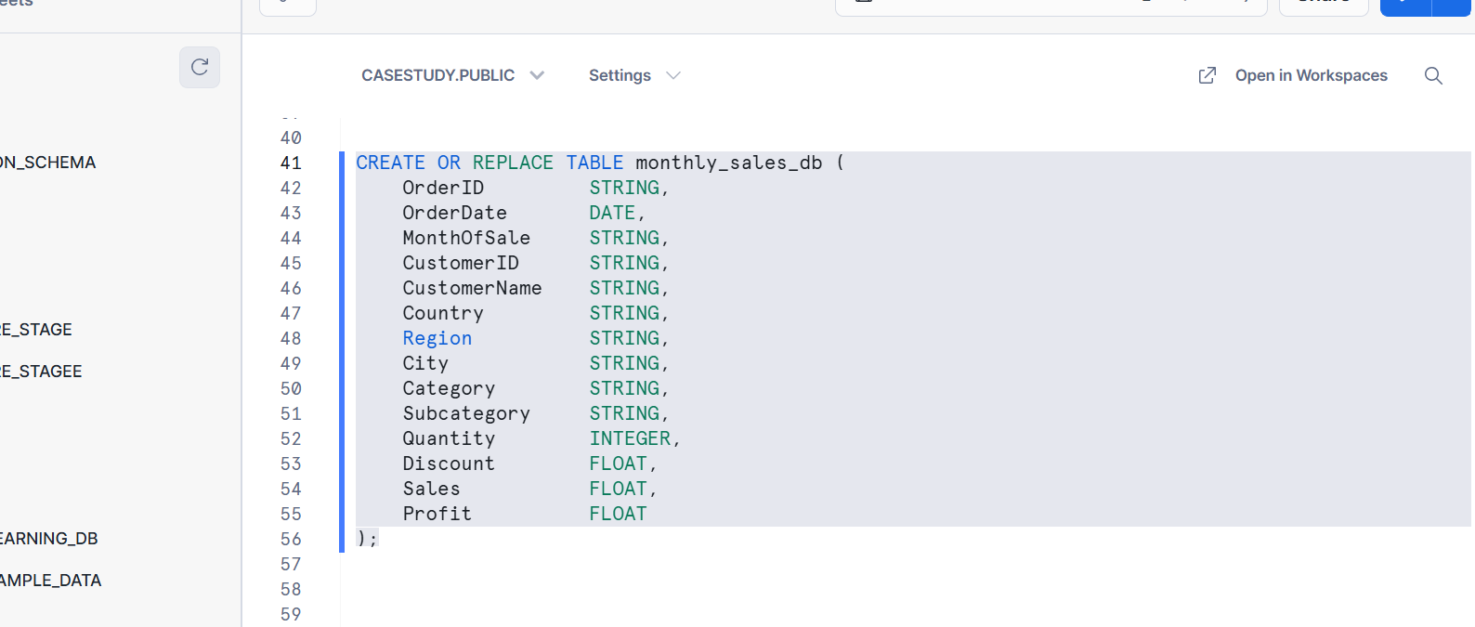

14.loading data from databricks to snowflake table using snowpark

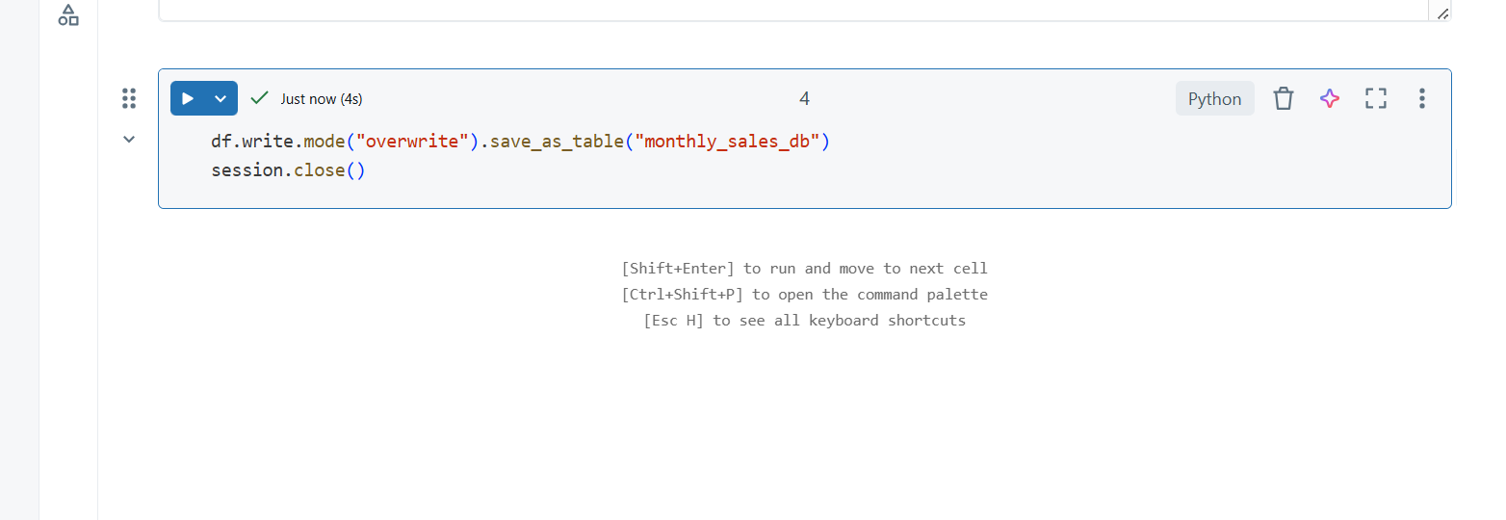

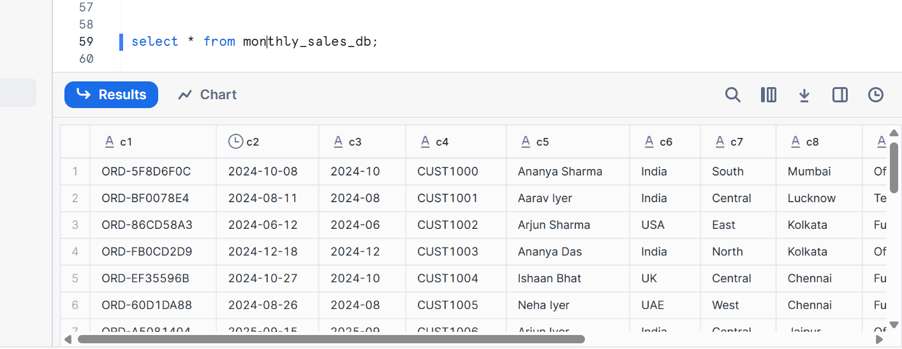

15.Connecting snowflake to power bi

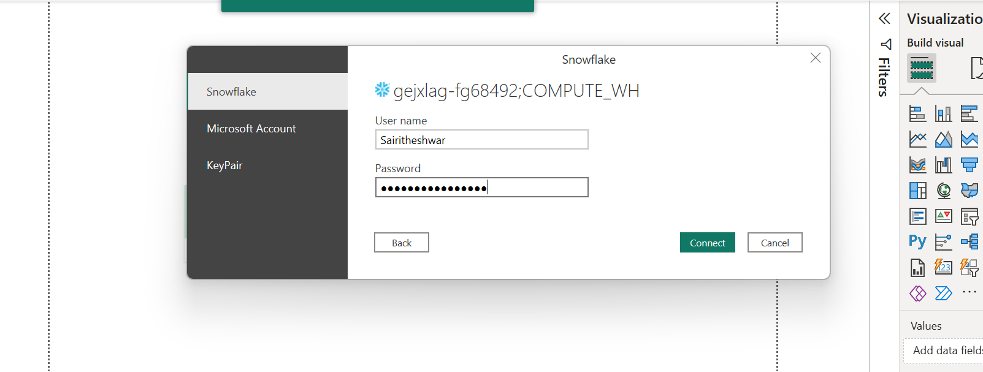

16.Loading data into power bi

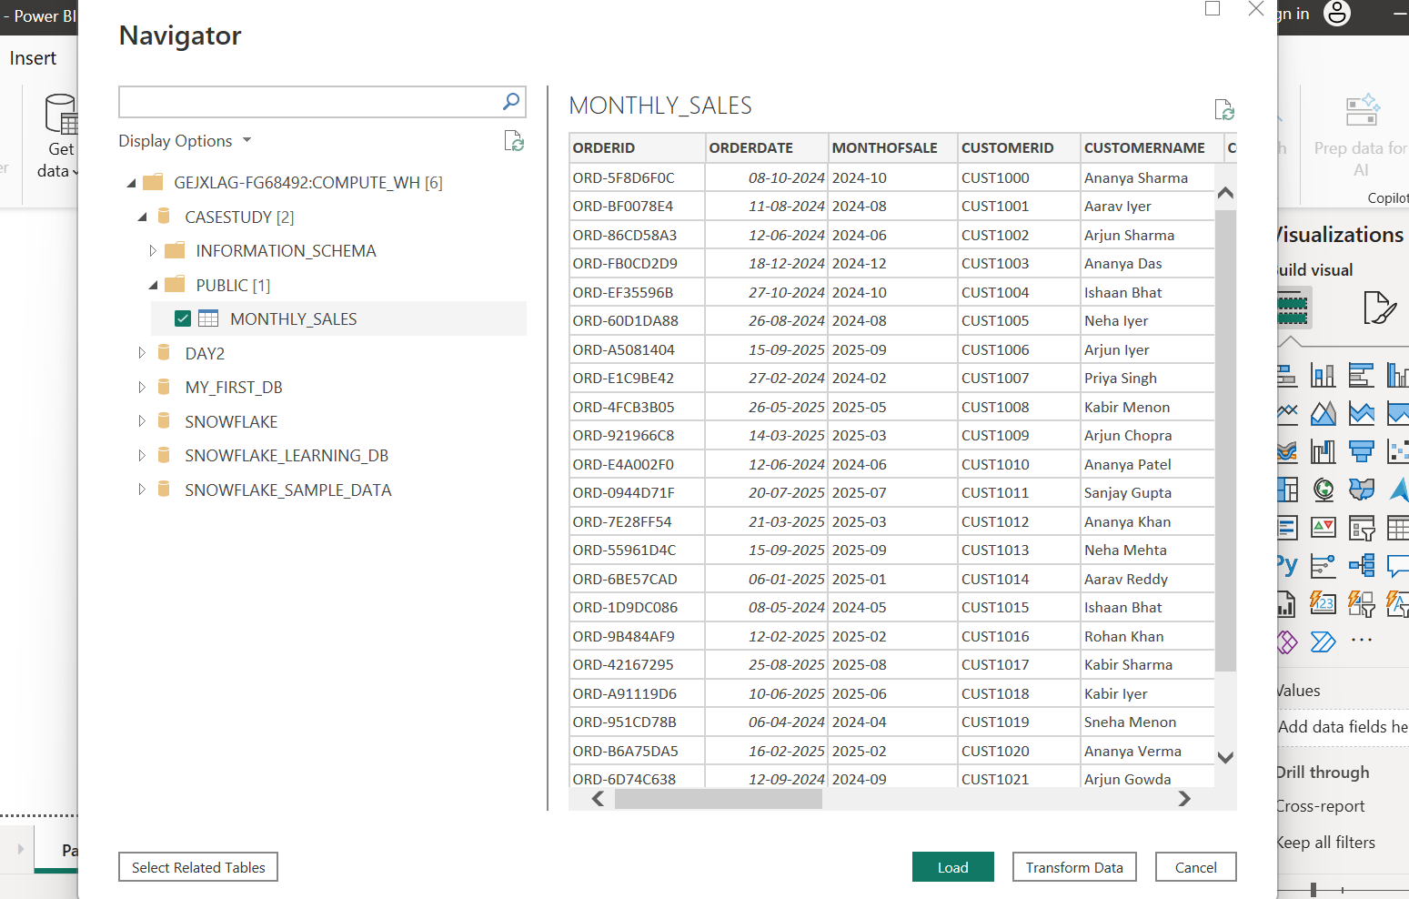

17.Creating reports

a.sum of sales by region and category

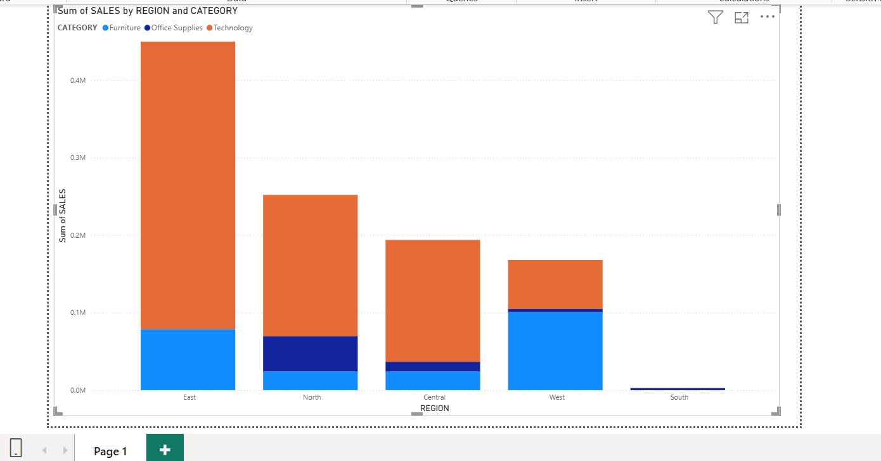

b. sales and profit by category

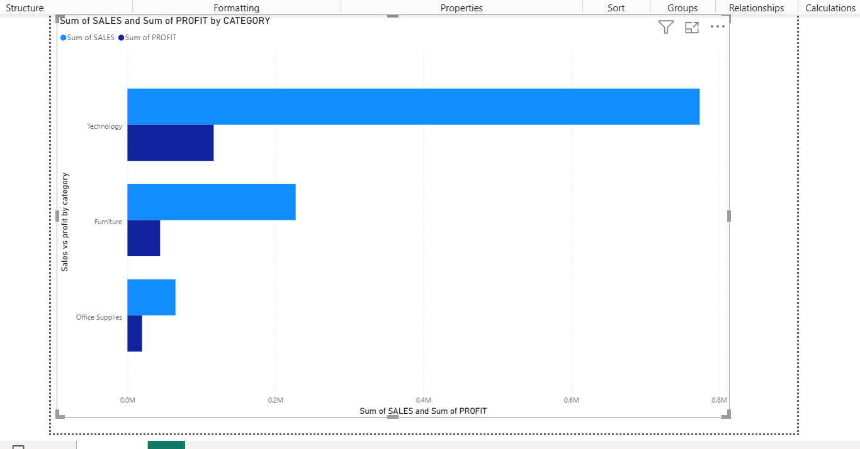

c.Sales by Country

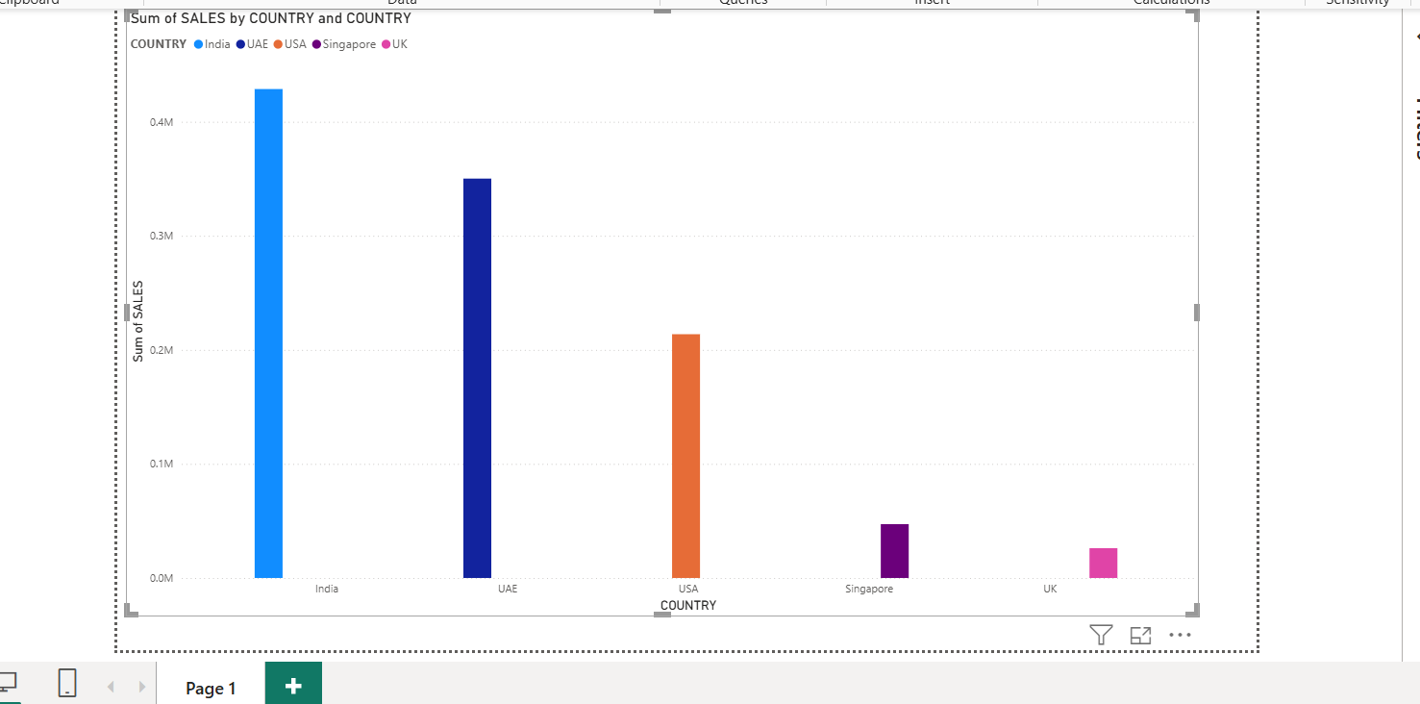

d.Sales growth by year

